**Host on Github:**

We first need to create a repository, and then we will create a GitHub page for our repo. Open **https://github.com/** and log in to your account. Click on the **New** button to create a repository.

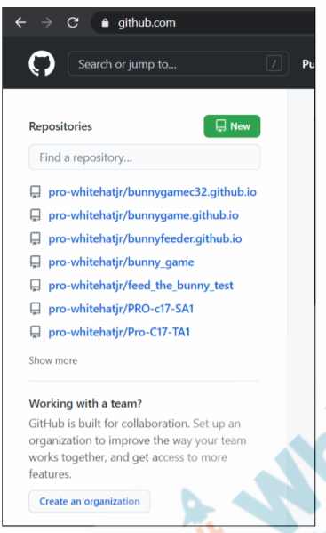

Now we need to **give a name** to our repository. Here we have to be very careful because we want to host this game on GitHub pages. When we do that, the repository name **should end with .github.io.**

**Note**: You can set any name for the repo but at the end of it, it should be .github.io.

**Example**: We can now set it as bunny_feeder.github.io.

Our repository should be set to the **public** and check the **Add a README** file box. After that, click on the button **Create repository.**

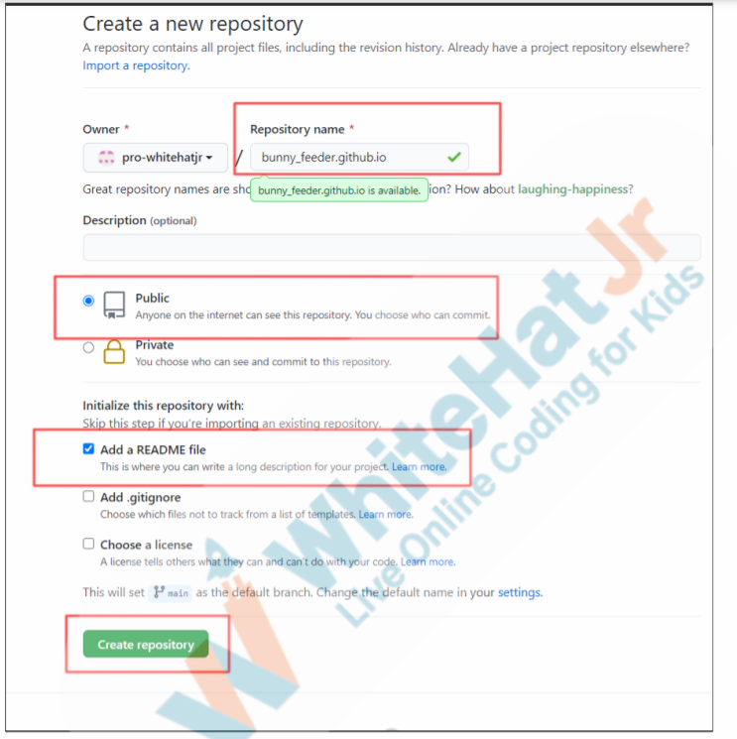

Now we are ready to add files to this repository. Click on **Add file** and from the dropdown menu click on **Upload files**. This will give the option to choose files from the computer. Select the folder from our computer and select all the necessary game files.

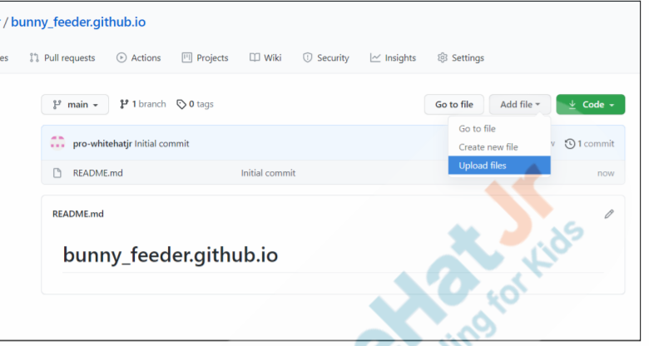

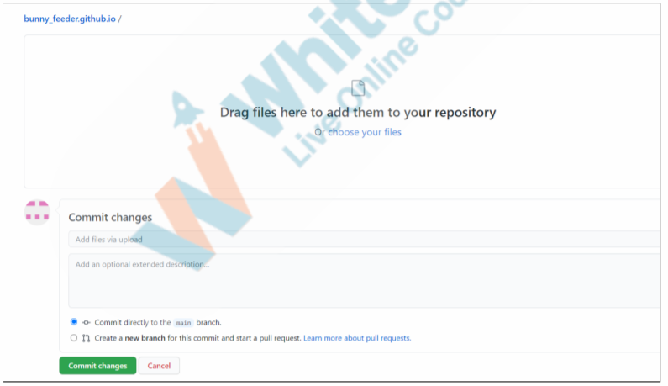

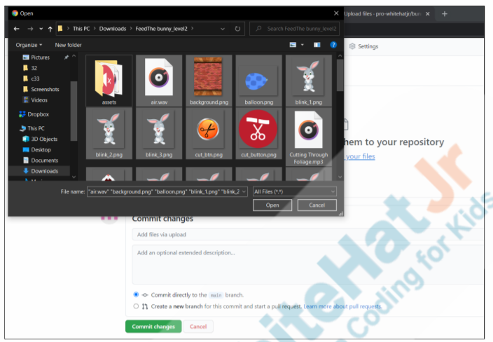

Once all the files are uploaded, check the option commit directly to the main branch and then click on **Commit changes**.

Click on the **Settings** button and select the **Pages** **tab**.

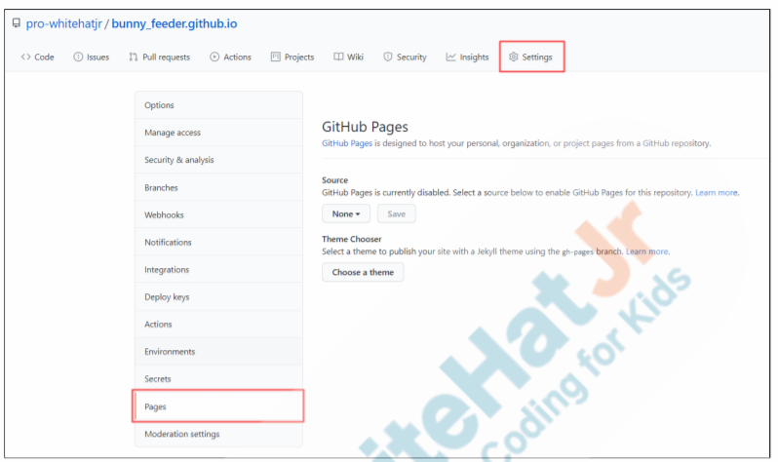

Here we will host our game on the GitHub pages. Select the **source** as the **main** **branch**, and it will choose the root folder by default, then click on **Save**.

This will reload the page and a **link should appear.**

Our game will be available at this link.

It may take a few minutes to publish the game, when our game is published the **link will turn green from blue**.

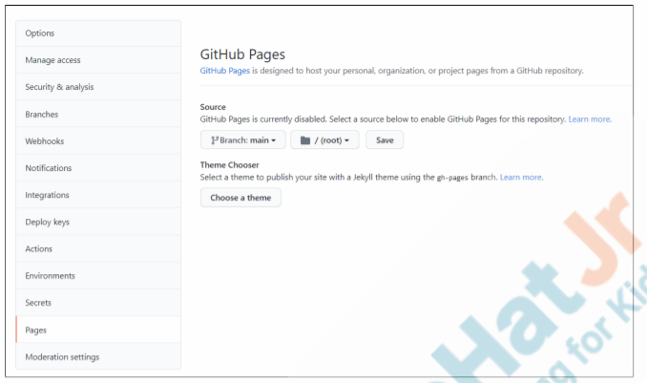

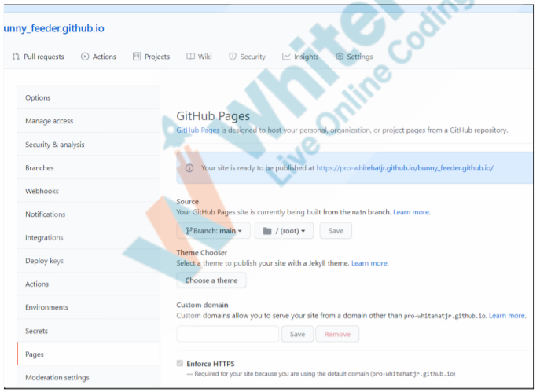

Refresh the page and now our game is published on the GitHub pages and the link is highlighted as green.

You can click this link to open and play the game, you can even share this, and it will work in any mobile browser too.

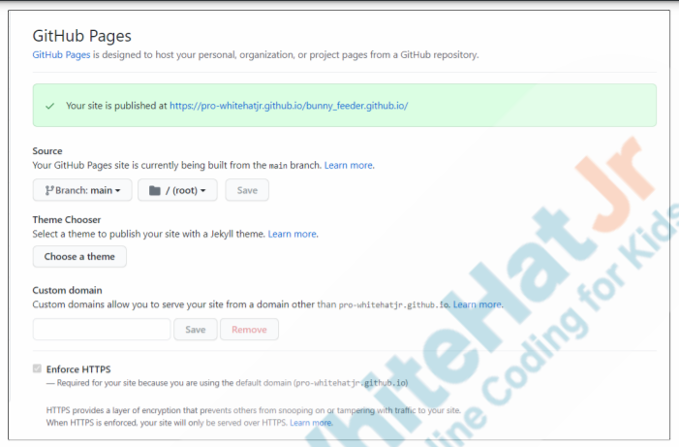

Copy this link and keep it saved in any notepad file or in sticky notes because we are going to use this link to create an APK file using Thunkable. Click on the link, and it will open your game in the browser.

**Thunkable:**

Open **www.thunkable.com** and log in to your account.

Click on the **Create New App** button to Create a New Project. Choose the name for the app and click on the **Create button**.

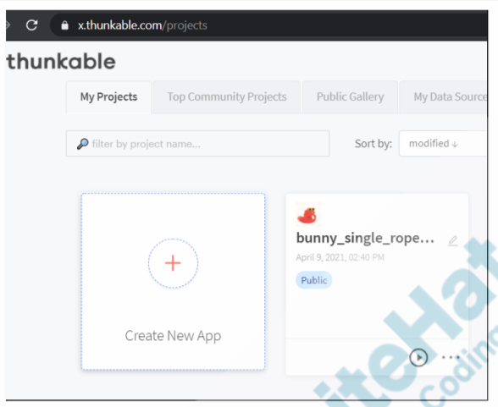

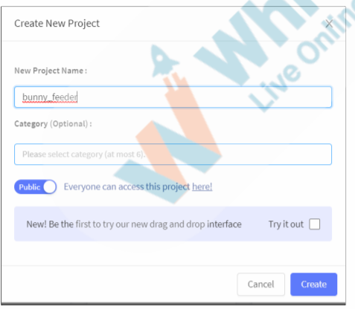

Drag and drop the Web Viewer component on the screen. This will open the options for the Web_Viewer1 on the right side.

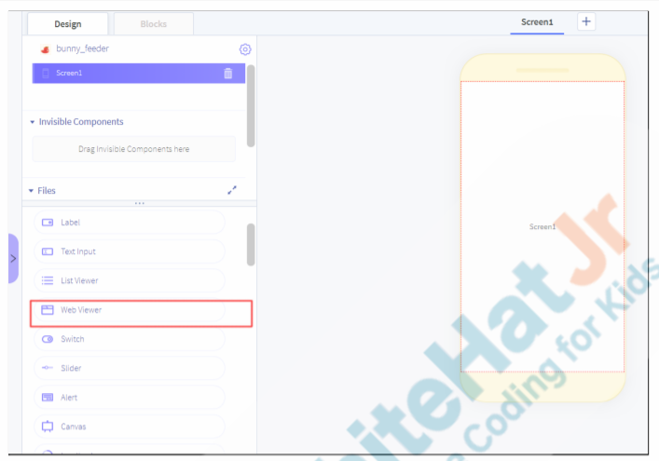

Paste the GitHub pages link in the URL section.

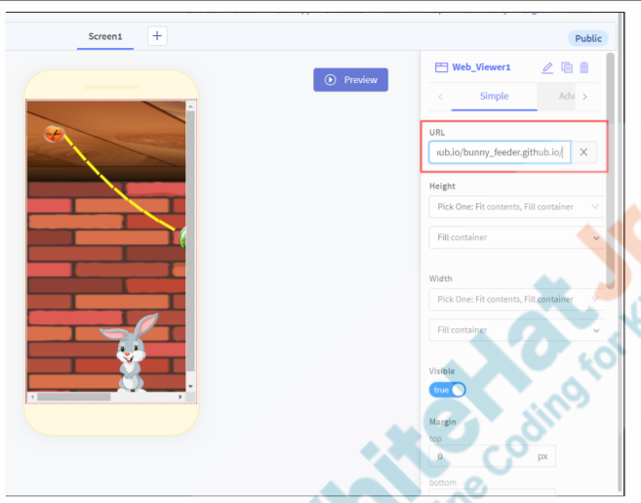

When the link is added, it will show the game preview as well. Now we just need to export the game in the required format of iOS and Android. When you select the choice of device it will send the download link on your mail, from that link we can download the installable file. Then transfer that file to the device and install it.

Note: It may take some time to receive the download link from Thunkable.

